DATE: 04.06.2019
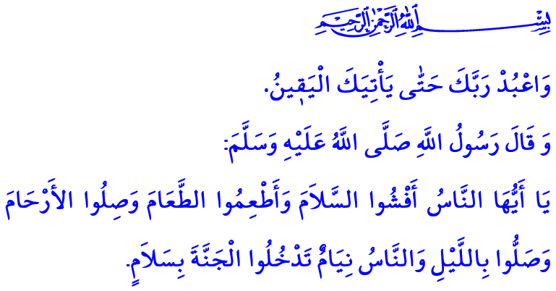
EID AL-FITR
Honorable Muslims!
We are grateful to reach once again the month of Ramadan whose beginning is mercy, middle is forgiveness, and end is salvation from the hell. Although we are sad that this blessed month has ended, we are also happy to have this morning of eid, with the feelings of fidelity and brotherhood spread all over the nation in waves. May endless praise and thanks be to the Almighty Allah (swt) who has let us reach the eid. May salat and salam be upon our Prophet Muhammad Mustafa (saw) who describes the days of eids as the days of joy, happiness and remembrance of Allah (swt). Eid Mubarak! I wish you all a happy eid!
Dear Believers!
We endeavored to seek the consent of Allah (swt) day and night, with fasting, tarawih and so on throughout the month of Ramadan. We tried to worship more, increase our acts of benevolence, increase our patience and repentance, and nourish ourselves with the Qur’an, and be embellished with taqwa (piety). While practicing the Sunnah of our Prophet (saw) with muqabala, we shared our food with our loved ones and the people in need at iftar tables. We prayed that our zakat and sadaqah save us from the hunger for wealth and property, and from the greed of the world. While we felt the joy of being ummah in our mosques where takbirs and salawats were heard, we also refreshed our awareness of servitude to Allah (swt) with itikaf. We reviewed the past years, repented for our mistakes and sins, and sought refuge in the forgiveness of al-Rahman. Alhamdulillah, in the end of such a bountiful and blessed month, we have reached the morning of the eid.
Honorable Muslims!
Eid is a bestowal of Allah the Exalted (swt) to His servants who fasted in the month of Ramadan. Today is the time to come close to each other, to open the doors of our hearts and homes, and to share our happiness. Today is the time to bring the hope, gratitude, and joy of being a believer who rejoined with the eid to all the places we go.
Then, let us experience this joy with our parents, who deserve respect and kindness most, with our wives who are our faithful companions and the witnesses of our bad and good days, and with our children who are the little sources of joy and hope in our houses. Let us visit family elders, relatives, neighbors, and friends.
Let us ask each patient around us of their condition, and make each old person around us happy. Let us add meaning to our eid with the smile of the orphans, and people in need and lonely.
In the morning of this eid, let us end the resentments and offenses between us as brothers and sisters with whom we turn to the same qiblah shoulder to shoulder. Let us strengthen the bonds of affection and trust between us by obeying the divine command of  “The believers are but brothers.”
Let us remember our relatives who passed away and our glorious martyrs who sacrificed their lives for our blessed homeland. Let us raise our hands and beg to Allah (swt) for our Muslim brothers and sisters in trouble, and pray that Allah (swt) let them experience the eids to which they will also reach in peace, tranquility, and security.
Dear Muslims!
We are bidding farewell to another month of Ramadan. We know that our duty of servitude to Allah (swt) is not limited to the month of Ramadan only. The mosques must be filled with people not only at tarawih but also five times a day; the tables of the people in need must be filled with food not only at iftar but also all the time; and the vitality of fasting and the generosity of sadaqah should be spread over the year. Indeed, the Almighty Allah (swt) invites us to spend every moment of our lives with the consciousness of servitude by stating in the Holy Qur’an, “And serve thy Lord until there come unto thee the hour that is certain.”
In accordance with this command of Allah (swt) and by responding to this divine invitation, let us continue the good traits we have gained in the month of Ramadan throughout our lives. Although the month of Ramadan has come to an end, may the barakah and sincerity of the month of Ramadan always be in our lives.
With these thoughts and feelings, I would like to wish a happy eid to the entire Muslim world, primarily our nation. May Allah the Almighty (swt) let this eid bring goodness to humanity.
I would like to conclude my khutbah with this hadith of Prophet Muhammad (saw): “O people! Spread salaam amongst you, share foods with each other, observe your kinship relations and establish prayer while people sleep so that you can enter heaven safely.”

Hujurat, 49/10.
Hijr, 15/99.
Tirmidhi, Sifat al-Qiyamah, 42. General Directorate of Religious Services

